PIDtoSIFtoGraph Plugin: Developper Guide

This document explains how to create an Eclipse project for Cytoscape plugin PIDtoSIFtoGraph, and generate a .jar.

# Running PIDtoSIFtoGraph with Eclipse

If you want to modify the plugin, using the IDE Eclipe, follow the next steps. You need to build it from the source code.

In the folder of your future project, copy the /src, /Jung and /plugins folders of the project.

Start Eclipse and choose this folder as working directory. Then click on File->Import->General->File System :

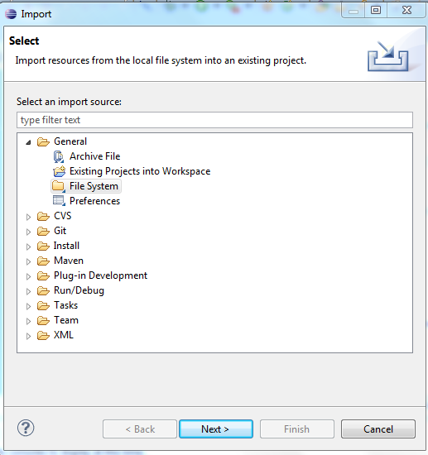

Then import the files in /src/main/java/de:

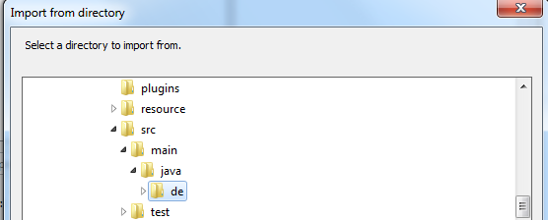

Select the files and make sure that "Create top-level folder" is checked:

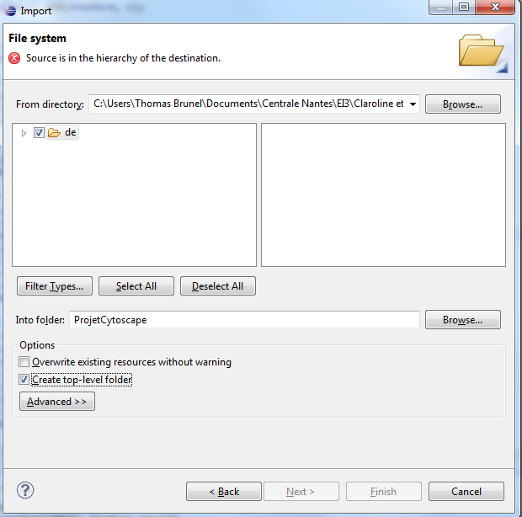

The next step consists in linking the libraries: right click on the project->properties-> java build path -> libraries->add external libraries. Take all files in /Jung and /plugins, except from PIDtoSIFtoGraph.jar.

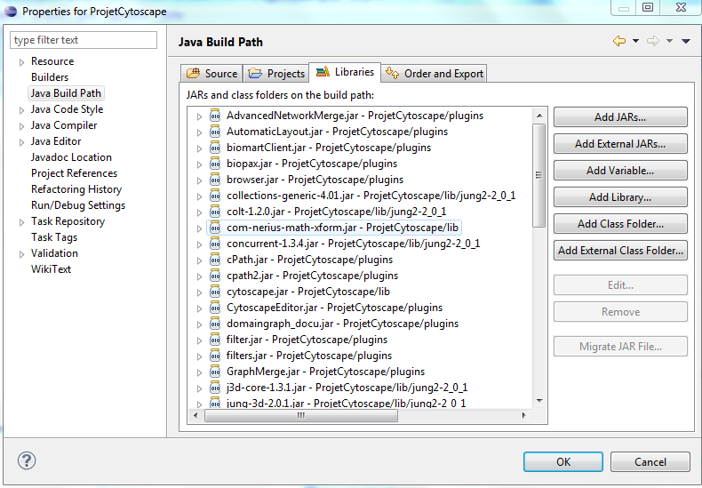

You also need to add cytoscape.jar as external jar. It should be in the directory \Cytoscape_v2.8.2.

Then copy the following files in the working directory:

* netView.props
* AFFY-44.adf.txt : this file maps the AffymetrixID to the GeneID
* UPtoGeneIDFULL.txt : this file maps the UniprotID to the GeneID
* vizmap.props

In the first package (de.bioquant.cystoscape.pidfileconverter), right click on the AbstractApp.java, and choose Run As → Run configurations.

Double click on Java Application. In the Main tab, in the Main class section, put "cytoscape.CyMain"

Arguments tab, put -p plugins

N.B.: If there is a version of PIDtoSIFtoGraph plugin in the files of Cytoscape, you can also put -p "path to the directory /plugins of cytoscape2.8.2"

For example : - p "C:\Program Files\Cytoscape_v2.8.2\plugins"

You can now run the project. Once configured, you can run directly the project next time.

# Creating the .jar file of the plugin with Eclipse

When the .jar file is created, it will be possible to use the plugin without Eclipse.

First, you need to create a new file at the root of your project: *MANIFEST.MF*.

In this file, put the following lines:

Manifest-Version: 1.0

Cytoscape-API-Compatibility: 2.8.2

Cytoscape-Plugin: de.bioquant.cytoscape.pidfileconverter.AbstractApp

Cytoscape-Plugin-Name: PIDtoSIFtoGraph

Cytoscape-Plugin-Version: 0.1

Be sure to include a return at the end of the last line or it may be excluded upon export.

Then, select file -> export -> java -> JAR file:

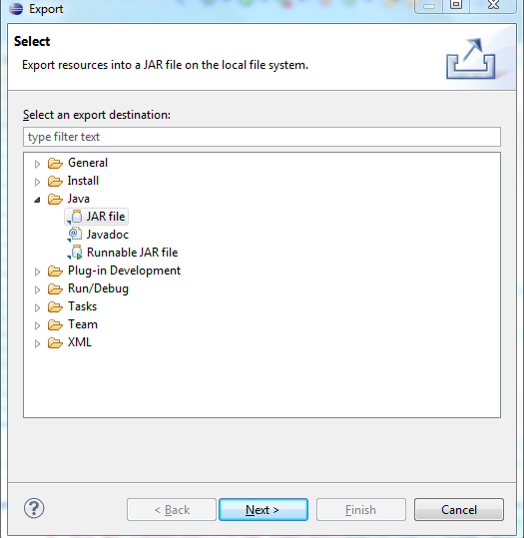

In the next window, select only the files in /src, and in the section "Select the export destination" choose the /plugins file of Cytoscape 2.8.2. ,with the name "PIDtoSIFtoGraph.jar".

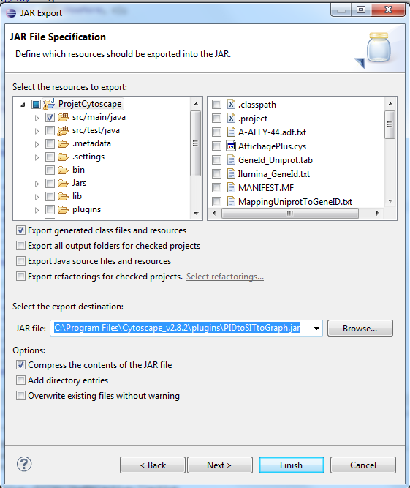

If you do not have the rights to generate the .jar in /plugins of Cytoscape, choose any other directory, but do not forget to copy the file in /plugins later.

On the next window (click Next, not Finish), click next, and then select the radio "Use existing manifest from workspace. Find the file MANIFEST.MF you just created:

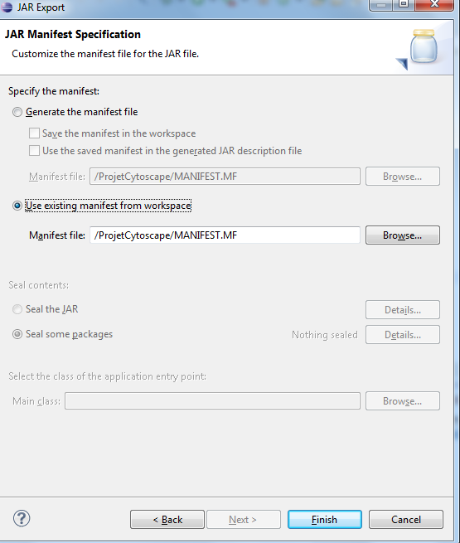

Then click on Finish and it should work (maybe you will have warning messages).

The created .jar file is now in the /plugins directory of Cytoscape (e.g. *C:\Program Files\Cytoscape_v2.8.2\plugins*).

Now that you created the plugin, if you want to directly launch Cytoscape and use PIDtoSIFtoGraph, follow the instructions of *2.2 Plugin* of the User Guide.

# About Cytoscape 3.0

In Cytoscape 3.0, the plugins have been replaced by apps. But apps and plugin are different, therefore the plugins of Cytoscape 2.x are not compatible with the new version of Cytoscape. ("Cytoscape 2.x plugins cannot be used in Cytoscape 3.0." p. 136 in Cytoscape 3 User Guide [http://www.cytoscape.org/manual/Cytoscape3_0_1Manual.pdf](http://www.cytoscape.org/manual/Cytoscape3_0_1Manual.pdf%20) )

However, due to backward compatibility concerns, the developer can use several methods to adapt the plugin and change it into an app: <http://wiki.cytoscape.org/Cytoscape_3/AppDeveloper/PluginPortingGuide>

Despite of this, adapting the code to make an app might take time.

If you want to set up Eclipse to develop Apps, the following link should be useful: <http://wiki.cytoscape.org/Cytoscape_3/AppDeveloper/SettingUpAnIDE/Eclipse>